

Interactive Media Teamwork

Nicholas Azzopardi HND2

### Task 1 – (P1.1)

List 10 Functionalities.

1. If you click on the play button the game will start.
2. If you click the Exit button the game will quit.
3. If the player hits the meteor a collision sound I played.
4. If you click on the “P” button the game will pause.
5. If the player collides with a meteor (enemy) the player’s health will be decreased.
6. If the player eats a planet/star the score will be incremented and also the size of the player will increase.
7. If the health reaches 0, the game over screen will load.
8. If you click on the retry button the game will start again.
9. If the timer runs out the game over screen will load.
10. When the game over screen loads the score the player got will be displayed.

### Task 2 – (P1.2)

Define:

* Repository – Is a specific allocated space for the projects you develop. This can be either locally on one’s computer or online like for example on GitHub. From the repository you can download the projects and view the files. Any type of file can be stored in these repositories.
* Commit – This means when you save your project online. It creates a checkpoint like idea so that if needed to go back to the previous version you can just use the Rollback feature.
* Issue – Issues are used to identify specific tasks or bugs that need to be carried out or fixed. These issues can be seen and replied to by the developer’s team that take care of the project in question.
* Sync – This is used to sync the local version of you project to the one that is found on GitHub’s repository. This is done so that the local and the remote are always up-to-date and mirrored.
* Add – In GitHub the command add is used not to add files to the repository but to bring new files to its attention.

### Task 5 – (P2.2)

Game screens

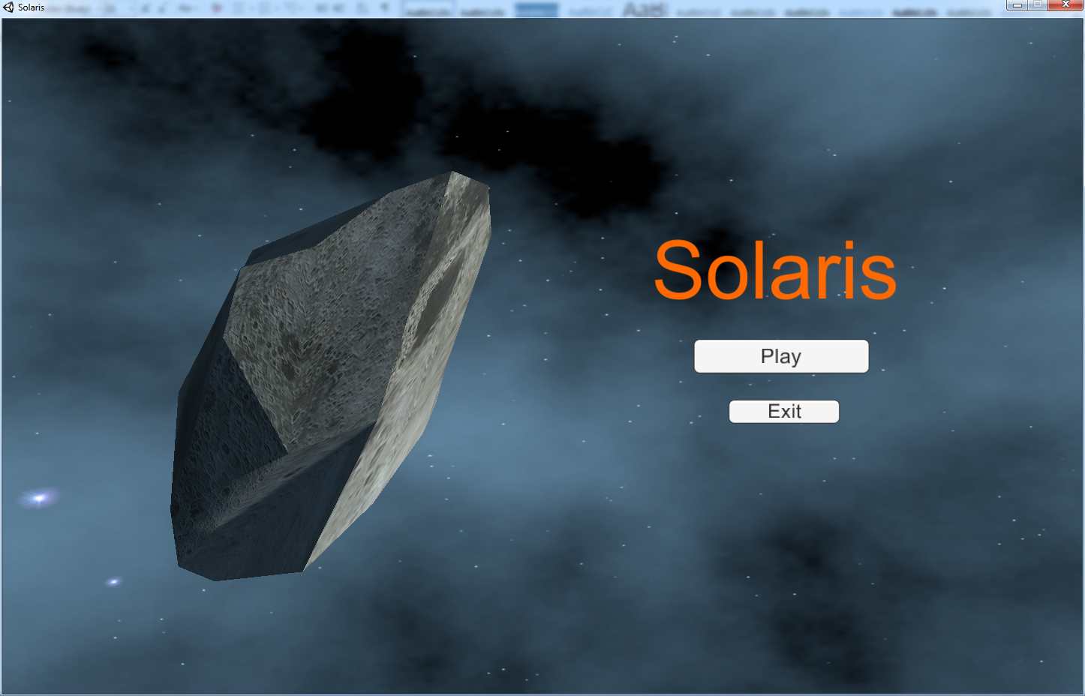

So basically this is the main menu where you have a play and an exit button. If you click the play button the game will load. See below.

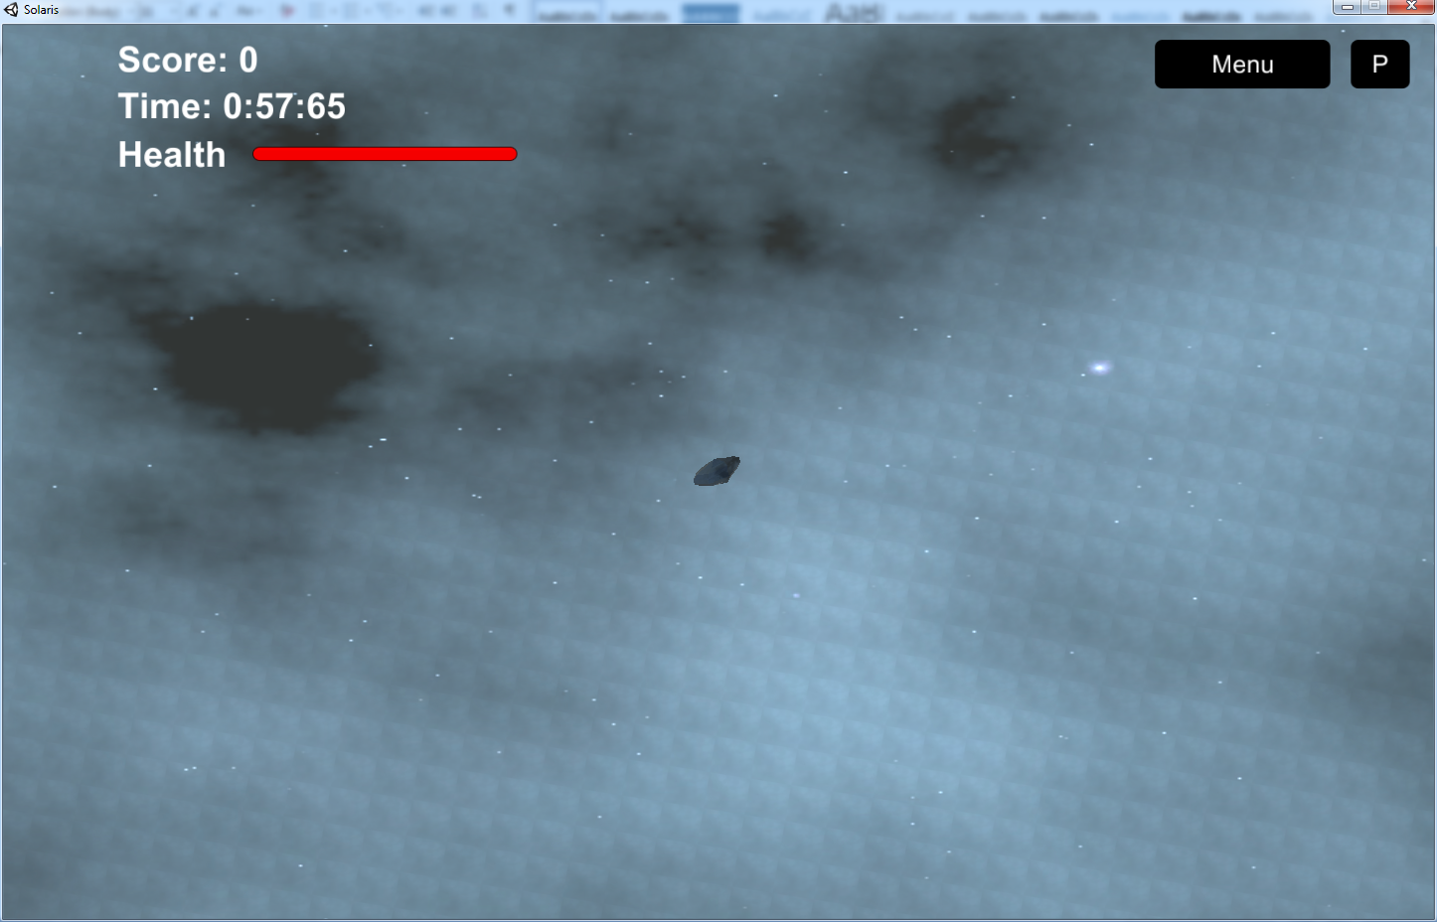

This is how the game starts. While you are playing you can pause the game with the top right corner button, and also return to the main menu by clicking the button and the menu level is loaded.

Id the timer runs out or health reaches zero the player will be shown a game over screen with score. See below.

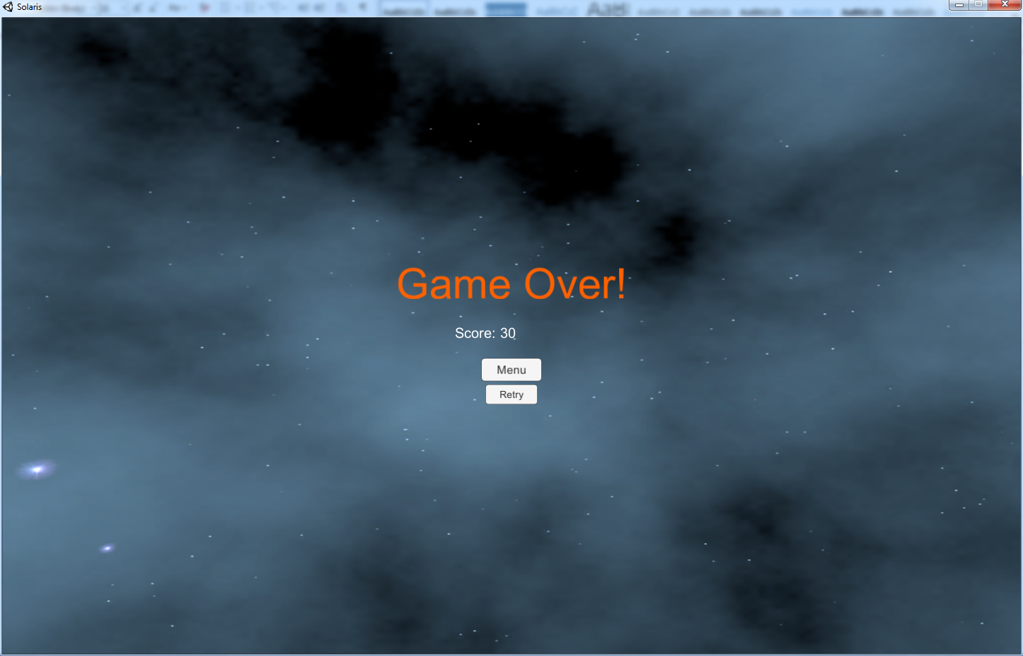

From here you can go to the menu or retry the game by clicking on the retry button. This will reset the game from the beginning.

### Task 4 – (P2.1)

Game Developer: <https://www.linkedin.com/jobs2/view/54407806?trk=jserp_job_details_text>

Skills:

* Advanced Proficiency with C/C++ or C# and/or Unity or Unity 3D
* 2+ Years of Game Development Experience
* Minimum of One Shipped Title or Experience Developing a Game with a Team
* Backend Network/Web Development Experience
* Proficiency with PHP
* Proficiency with Relational Databases
* Experience with 3rd party SDKs on Android or iOS
* Bachelors or Higher in Computer Science or a Similar Field

Game Designer: <https://www.linkedin.com/jobs2/view/62732244?trk=jserp_job_details_text>

Skills:

* A minimum of 5 years’ game design experience including experience on a shipped product
* A passion for collectible card games
* Excellent written and verbal skills
* Absolute passion for playing and making computer games
* Experience designing simple to understand yet still deep game systems
* Experience designing fun cards for a CCG or CCG-like game.
* Excels in a team environment

Sound Engineer: <https://www.linkedin.com/jobs2/view/67064300?trk=jserp_job_details_text>

Skills:

* Have knowledge of digital signal processing
* Create innovative acoustic design scheme and set audio targets for future products
* Perform audio regression tests on shipping products and generate audio performance reports
* Validate hardware/software and debug issues
* Develop automated test tools (Sound Check, LabVIEW)
* Attend and run cross-functional engineering meetings
* Dive into and take ownership for critical design issues
* Lead design reviews
* Build design processes to continuously improve performance and quality
* Travel to support engineering builds if needed
* Bachelor’s degree in Electronic Engineering or related field
* 3+ years of relevant experience in audio technology development or integration
* Experience with concepts of acoustic design, measurement instruments, and automation software like Sound Check and LabVIEW
* System level integration experience – Audio, Power, Battery management, RF, ESD, etc.
* DFx (cost, test, manufacturing) experiences
* Experience in the following areas:
  + Acoustic simulation
  + Mechanical integrations
  + Audio signal processing
  + Audio electronics
  + Audio transducer design
  + Acoustic test and measurement
  + Experience with acoustic test instruments (e.g. Sound Check, MLSSA, LMS, B&K, Audio Precision)
  + Subjective audio quality evaluation
* Master’s degree
* Mobile electronics and wireless technologies
* Strong analog design experience
* Proven track record of delivering high volume consumer electronic devices

As an area of expertise I would choose the developer area. I believe that to be able to develop applications or games one needs a very strong logic which I poses. Programming is all based on logic. I like design as well as I am actually studying to become a web designer, design is an important matter for me. My ideology is that design and development are perfectly tied together and for someone to know both at the same time is something really great as you can design and make your designs come to life. And let’s face it, designs mean nothing without developers to make them functional. And for me the fact that you can make something kind of alive is a great satisfaction. And in that way if you have an idea and you make a design concept as a developer you can actually develop it and make it real.

### Task 5 – (P2.2)

In Idea generation a developer sees that the idea presented by the designers is feasible and that can actually be developed. Also the developers must check for other games which are similar to the game ideated and check whether there are same features and/or story.

In story boarding and design of the game a developer must give importance to how the game is going to play and what type of mechanics will it involve. The developers must study how the game is going to navigate from one screen to another as to sketch a plan on how scenes will be structured.

In the creation of the game design document the developer must give all the details on how the project will be developed and in how many stages it will be spread.

In the Implementation of functionalities the developer must use the game design document, the idea and storyboards of the game and develop what was planned exactly. While should he find a problem with implementing a specific feature, a consultation between the whole team, would be carried out and a workaround must be found.

In the deployment and support of the game the developer must ensure that the game is complete and functional during deployment. As the game is deployed the developer must keep checking the game for inconsistencies and listen to the players to see if they encounter a bug. If a bug is found the developer must fix these issues by updating the game.

### Task 6 – (P3.1)

As the repository was already created I will post a screen shot of the name of the Project.

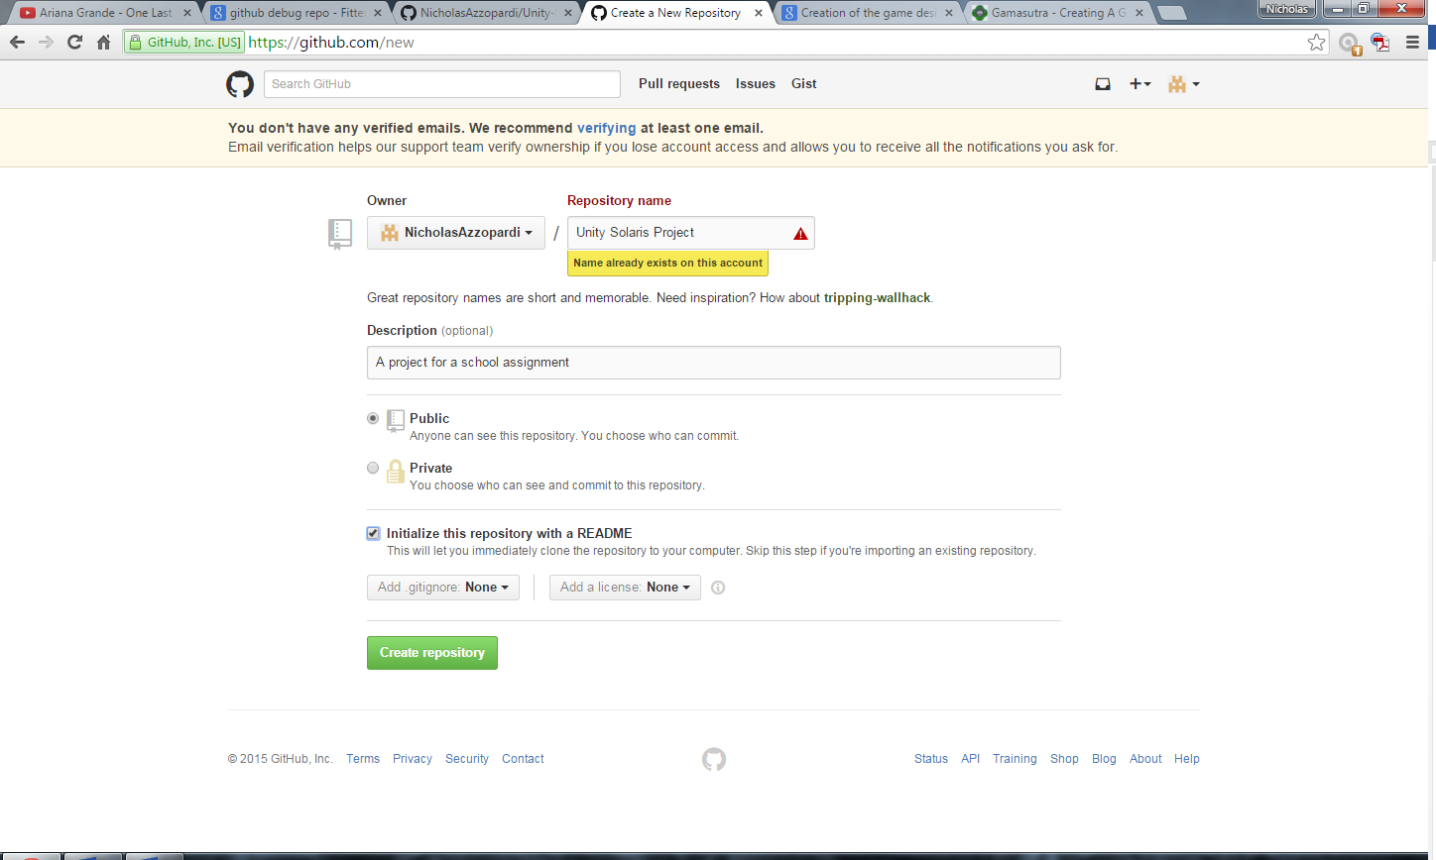

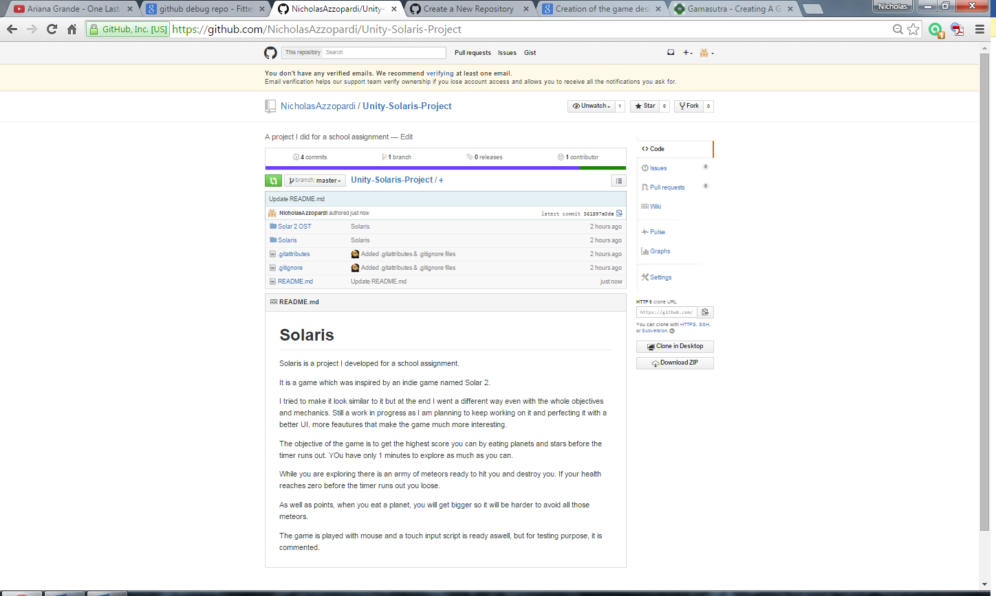

### Task 7 – (P3.2)

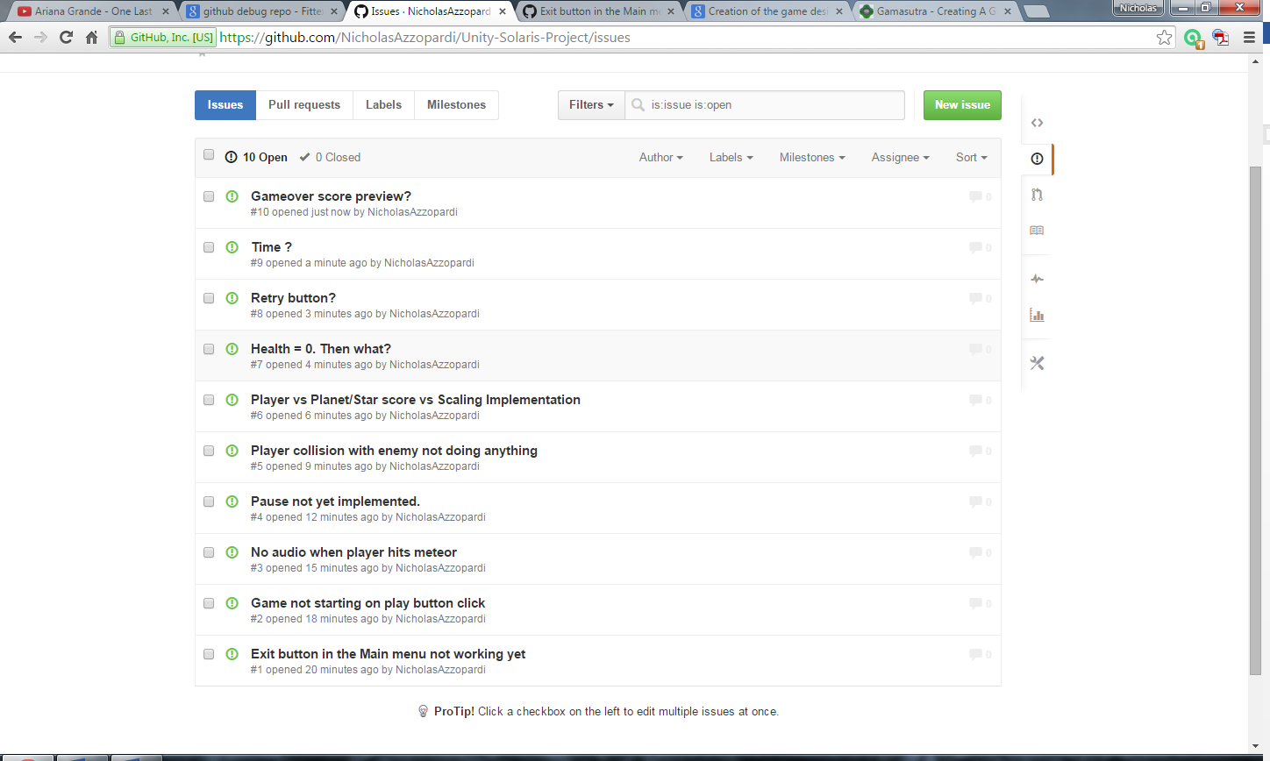

### Task 8 – (P3.3)

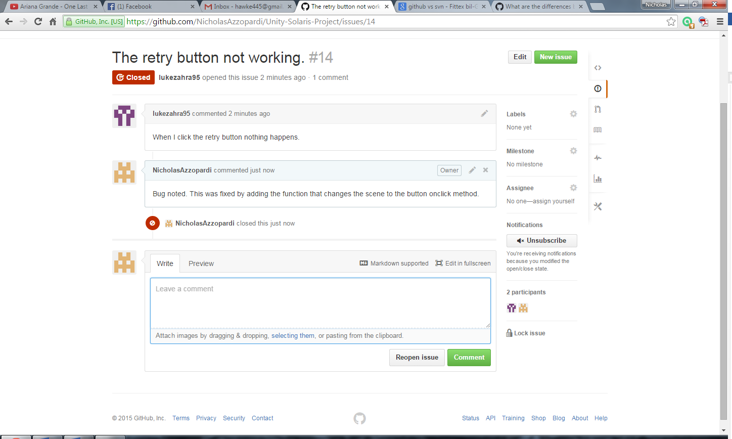

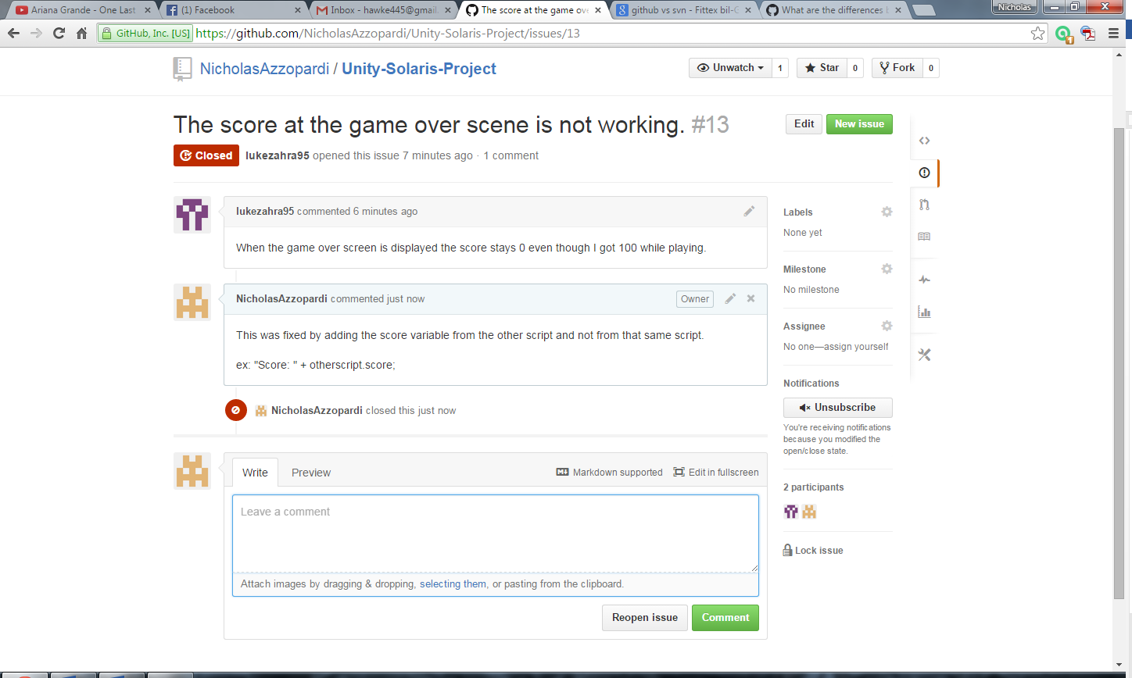

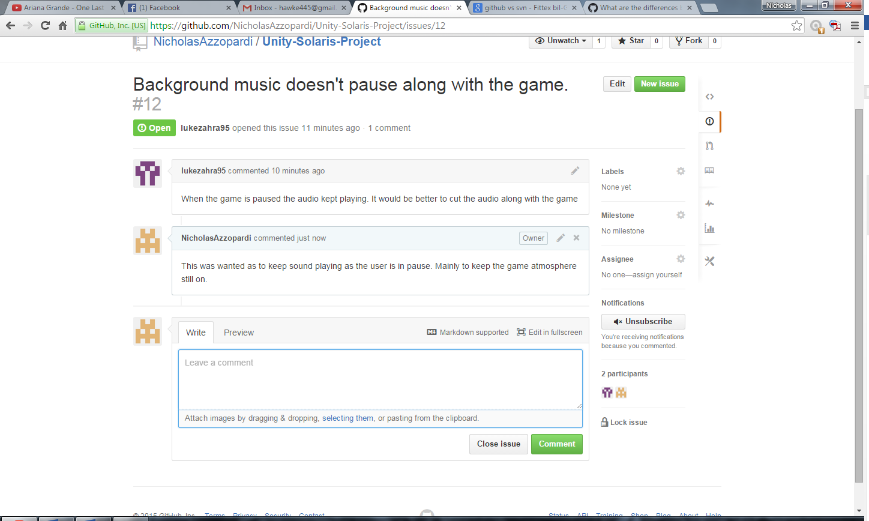

### Task 9 – (P4.1)

Issue of background music not working created. 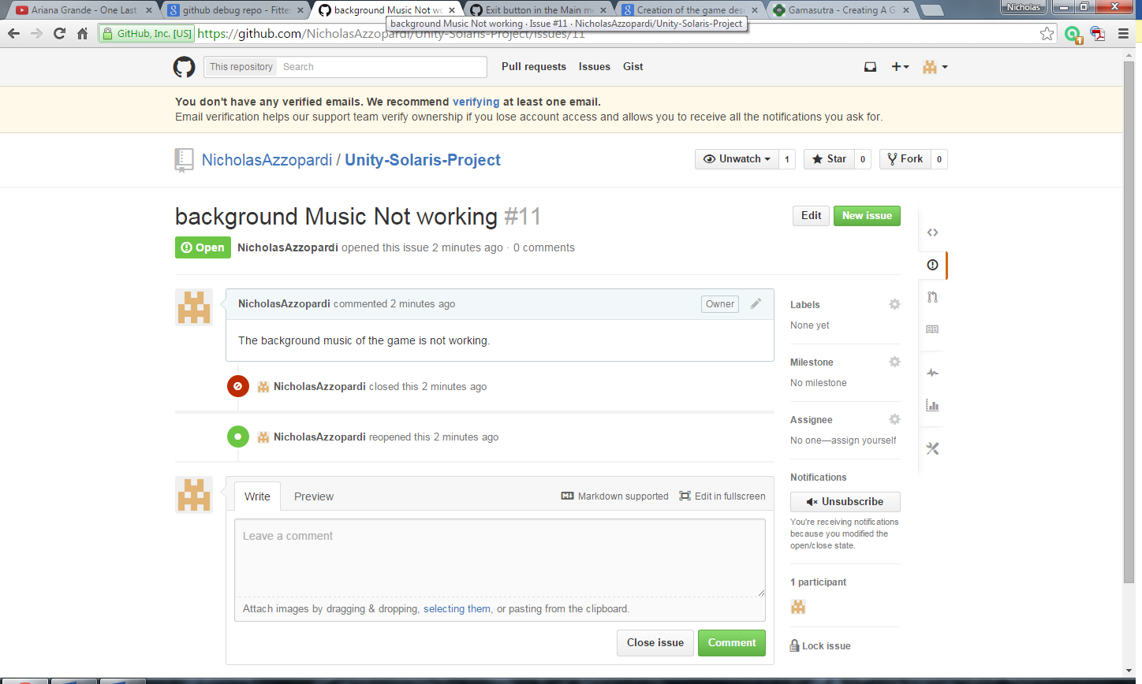

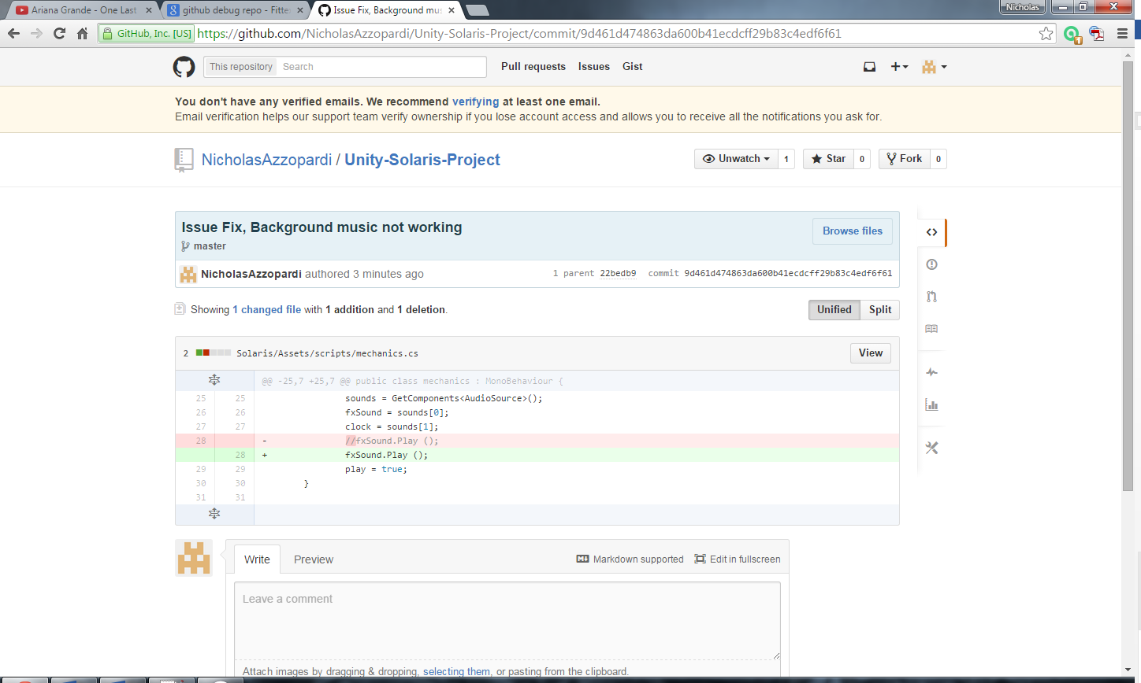

### Task 10 – (P4.2)

As an initial idea, it was completely different from the end result. As it changed during development new ideas were thought and started to be implemented along the development of the game. Although the result is pretty neat, I still wanted to add some major functionalities updates. Starting from the physics, I would’ve liked to adjust the physics to be more accurate and more realistic in zero gravity. Of course with my knowledge limitations it would have taken much more time than it did. Other features are to dynamically move the enemies, not as single block but actually disperse and then come back from every direction at random speeds one by one. Another features was to add more modifiers, as to add speed boost or some kind of temporarily GPS arrow that points to planets and stars as to find them faster. Also to add a time power up where it freezes time for 5 seconds as to gain time. A major improvement I would want to improve is the UI. At the moment it is very simple and boring so it definitely could have been done better by adding more thought to it and making an actual plan.